Maffra Secondary College

2025 SPORTS UNIFORM ORDER

 | SIZING CHART FOR SPORTS UNIFORM
 | Polo's and  Track Jackets | 4 | 6 | 8 | 10 | 12 | 14 | 16 |  | Shorts & Track pants | 4 | 6 | 8 | 10 | 12 | 14 | 16
 | To Fit Chest  Measuring: | 60 | 64 | 68 | 75 | 80 | 86 | 90 |  | To Fit Waist  Measuring: | 56 | 58 | 60 | 62 | 64 | 66 | 70
 | Polo's and  Track Jackets | S | M | L | XL | 2XL | 3XL | 4XL |  | Shorts & Track pants | S | M | L | XL | 2XL | 3XL | 4XL
 | To Fit Chest  Measuring: | 95 | 100 | 105 | 110 | 115 | 120 | 125 |  | To Fit Waist  Measuring: | 75 | 80 | 85 | 90 | 95 | 100 | 105

Winter Jacket Sizing Mens
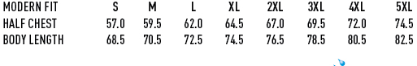
Winter Jacket Sizing Ladies
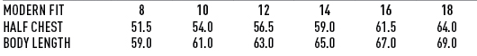
-------------------------------------------------------------------------------------------------------------------------------------------

MAFFRA SECONDARY COLLEGE

Date______________ Student Name_____________________________________________
 | 8J | 10J | 12J | 14J | 16/XS | 18 | 20 | S | M | L | XL | 2XL | Total
Sport Polo $60.00
B Sport Shorts $45.00
G Sport Short $45.00
Track Top $100.00
Track Pant $70.00
Winter Jacket $100.00
Hat $15.00
Polar Fleece $50.00
White Polo $35.00
Dress $80.00
Grey Shorts $25.00
TOTAL

PAYMENT DETAILS

NAME OF CARDHOLDER: ………………………………………………………..… AMOUNT: …………………………………….
□ Bankcard □ Visa □ Mastercard □ Cash □ Cheque CCV

Expiry Date: …….. / ………. Signature: …………………………..……………………………….

All School Uniform items can only be purchased from the college.

